SPARK: Simple Play Adaptations to Reference for Kids

PowerLink 4
Description: | Image:
The PowerLink 4 is a switch interface that enables electrical appliances/devices to be controlled with switches either wired or wireless. One or two devices can be plugged into the PowerLink and either one or two switches can be used to activate the devices. There are 6 different modes of control including direct, count (which shows the number of switch activations for easy data collection), two-switch (which behaves like direct selection, but both switches must be activated), timed seconds or minutes (runs the appliance for 1 - 99 seconds), and latch (first activation turns the appliance on, and the 2nd activation turns the appliance off). This device comes with 2 buddy button switches but other switches could be used with this device.  Purchasing Information | 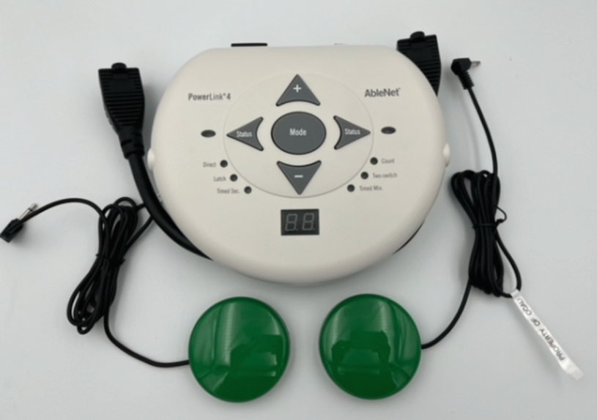  Demo Video  Users Manual  Quick Start Guide  Trouble Shooting Guides

Who Might Benefit?
Those who…
• Benefit from switch use or currently use switches as an access method because they are unable to access typical classroom activities or common electrical appliances.

Why Use?
Provides an opportunity to…
• Activate an appliance for participation in classroom activities, i.e. cooking, music, math, literacy, etc.
Instructions for Use: | Adaptation Ideas:
Environmental Considerations  - Use on any flat surface (e.g., floor, tabletop, or wheelchair tray) with easy access to an electrical outlet.  Positioning  - Use in any position where the device attached to the PowerLink can work safely, see the device, and access the switches.  Alternate Positioning  - Alternate positioning of side-lying, tummy time position, lying on the back, kneeling, etc. may also be possible however as mentioned above the device attached to the PowerLink must be in a position to be able to work safely, and the child needs to be able to see the device and access the switches.  Basic Play/Use  - Plug the PowerLink into any AC wall outlet with the cord provided and turn the device on.  - Plug appliance(s) to either power cable on the side of the PowerLink and turn the appliance(s) on.  - Test your AC power connection by pressing the appropriate test button. The attached appliance should activate.  - Attach any corded, single switch(es) to the corresponding switch jack(s).  - Press the mode button until the "direct" mode LED lights up.  - Press and hold switch(es) to activate their corresponding appliances. Release to turn off.  Extended Play/Use  - Five other modes are available and useful for a variety of reasons. These can be activated by pressing the mode button in the middle of the device until the desired mode type is located.  - Count: Responds like Direct mode in that pressing the switch turns on the appliance connected to the PowerLink and releasing the switch turns off the appliance. The device only works when there is sustained pressure on the switch. In count mode, it also shows in the viewing window the number of switch activations. This can be useful if data is needed to track progress in initiating and interacting with the appliance to inform decisions of choice of activities, success rates, etc.  - Two-Switch: Responds like Direct mode, however, two switches need to be plugged into the two Powerlink ports and then both switches need to be activated/pressed at the same time to run the appliance. This would be useful as a cooperative/collaborative activity between two children. It may also be helpful if an activity requires a quick override to stop the activity. This could be accomplished by having an adult activate and deactivate the second switch.  - Timed Seconds: Runs an appliance from 1 to 99 seconds when the switch is activated. The time is sent by pressing the up or down arrows on the top of the PowerLink. This would be useful for children who are unable to press and continue to hold a switch to activate the appliance. Adjusting the time could help when the device is activating a story on an audio player so that small sections or pages of the story can be played all at one time.  - Timed Minutes: Runs an appliance from 1 to 99 minutes when the switch is activated but provides a longer time for the device to be activated than the previous mode. This may be useful for listening to a longer audiobook at bedtime, turning on lights at bedtime, etc.  - Latch: The first activation turns the appliance ON and the second switch activation turns it OFF. This is useful for children who do not have the sustained grasp to press the switch to keep an appliance on but can press it briefly to activate the device. This would be useful anytime having a device on for an indefinite amount of time is needed or the child needs to select the time when something begins and ends.  Play/Use with Others  - The “Two-switch” mode provides an opportunity for a child to engage in collaborative/cooperative play with another child or adult since pressing both switches are required to activate the appliance/device.  - During group time, have them share their feeling and why they feel that way.  - If a child identifies a feeling other than “happy” or “surprised”, encourage the group to talk about what could be done to make the child feel better. | Optional Additional Materials/Supplies  - Velcro  - Dycem, non-skid matting, cabinet liner  Stabilize It  - Stabilize on a flat surface with either Velcro or a non-skid matting such as Dycem or cabinet liner.  Add Sensory Cues  - Add textures, colors, or picture symbols combined with words could be added to the switches to assist the child who needs more information about the function of the switch or encouragement to engage with the switch.  Communication Support  - Communication boards could be developed with keywords needed to engage in the specific activity the PowerLink is being used to support (cooking, art, math, literacy, gardening, etc.) Additionally, words such as more, go, stop, start, stop, and help should be included to support the actual function of the device.  Alternative Uses  - Different types of switches could be trialed if the included switches are not usable by the child. The OCALI lending library has several kits with multiple types of switches that can be trialed.

Resources:

In addition to the wired switches provided in the kit the Powerlink 4 is also directly compatible with a variety of AbleNet wireless switches. If a wireless setup is needed a Jelly Beamer Switch and PowerLink 4 can be borrowed separately from the OCALI lending library. Directions for setting up the wireless switches can be found in the Users Guide: Instructions For Use PowerLink 4 Control Unit (pg 6).

PowerLink Switch Ideas for Use https://literacyaccessforall.org/storage/ocali-ims-sites/ocali-ims-tdla/documents/PowerLink_Ideas.docx

AbleNet U Power Link Training Video https://youtu.be/xlwQQS6QcW4?si=CTTAEtcmrooQQjwL

AbleNet Technology Tidbits Video – PowerLink https://youtu.be/vlu5RXaLNcM?si=fDshPymL7LgUsWAd

Additional Considerations:
Warning: Do not use this device near water due to the potential of electrocution.

Ohio Early Learning Standards:
- SC: Science Inquiry and Application: Develops ability to reason about cause and effect. (1.b.)
- Because this is an access tool this may support multiple areas of the Ohio Early Learning Standards depending upon the paired activities with the device.

Words to Encourage Play/Use
More  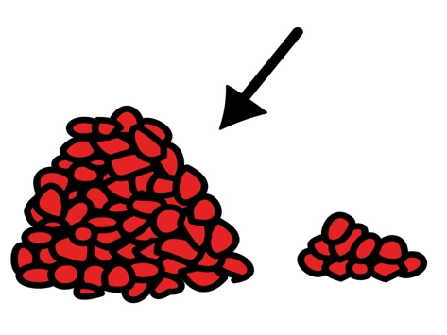 | Go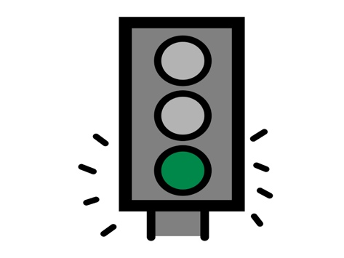 | Help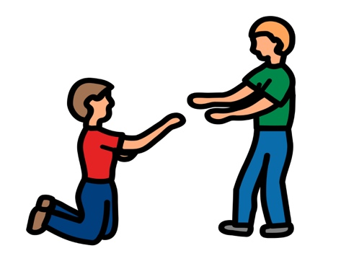
Push | Stop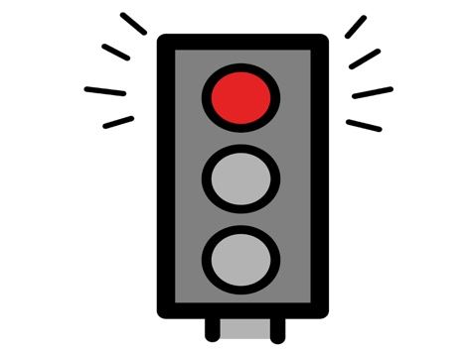 | Ready
On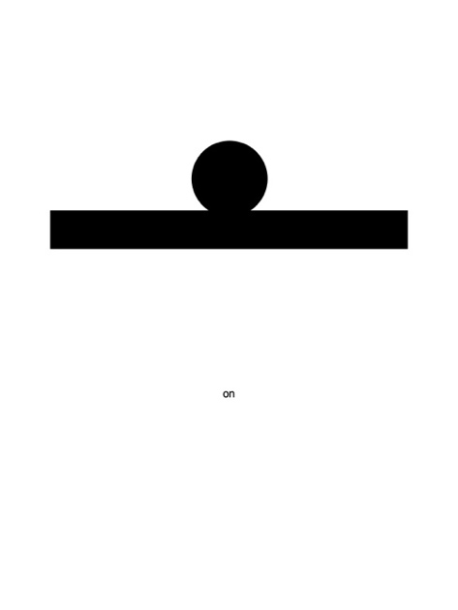 | Off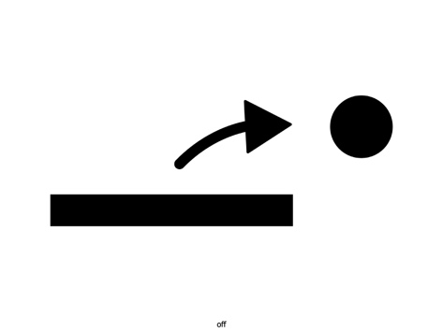 | Done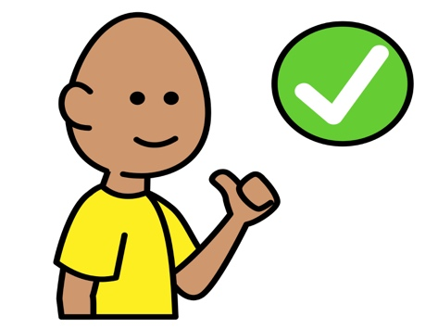
*”Adaptations” adapted from: Haugen’s Modes for Adapting Toys based on materials from the "Let's Play" Project at the University of Buffalo
PCS is a trademark of Tobii Dynavox, LLC. All rights reserved. Used with permission.

